Lab: Asynchronous Programming
Submit your solutions in the SoftUni judge system at:
https://alpha.judge.softuni.org/contests/asynchronous-programming-lab/4369
Working with Remote Data
For the solution of some of the following tasks, you will need to use an up-to-date version of the local REST service, provided in the lesson’s resources archive. You can read the documentation here.

Requirements
For each task, you need to install all dependencies using the "npm install" command.
Then you can start the front-end application with the “npm start” command
You also must also start the server.js file in the server folder using the “node server.js” command in another console (BOTH THE CLIENT AND THE SERVER MUST RUN AT THE SAME TIME)
At any point, you can open up another console and run "npm test" inside the tests subfolder for the problem to test the current state of your application, it’s preferable for all of your tests to pass locally before you submit them to the judge platform, like this:
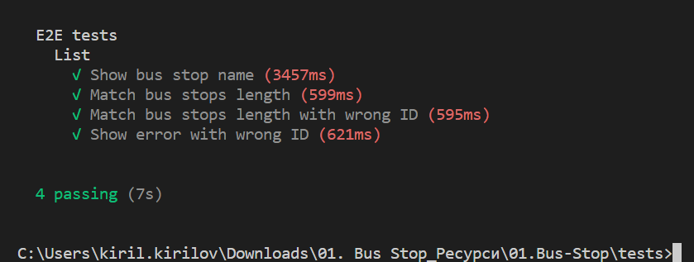

1. GitHub Repos
Your task is to write a JS function that loads a github repository asynchronously with AJAX. You should use the Fetch API. Obtain the data by making a GET request to the following URL: “https://api.github.com/users/testnakov/repos”
Transform the body to text with res.text() and in the second then() block of the Promise replace the text content of a div element with id "res" with the value from the response. Do not format the response in any way.

Examples
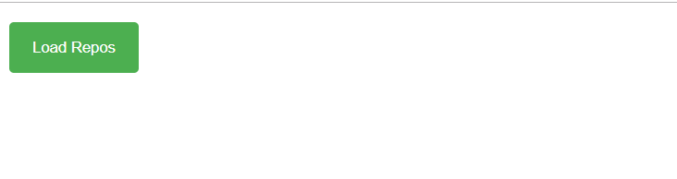
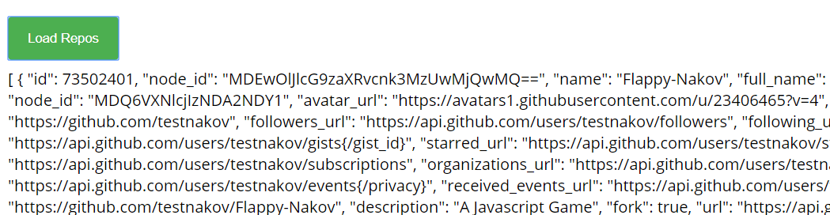

2. Github Repos By Username
Your task is to write a JS function that executes an AJAX request with Fetch API and loads all user github repositories by a given username (taken from an input field with id "username") into a list (each repository as a list-item) with id "repos". Use the properties full_name and html_url of the returned objects to create a link to each repo’s GitHub page. If an error occurs (like 404 "Not Found"), append to the list a list-item with text the current instead. Clear the contents of the list before any new content is appended. See the highlighted lines of the skeleton for formatting details of each list item.

Examples
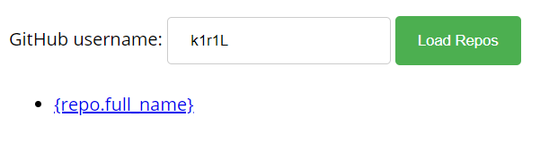
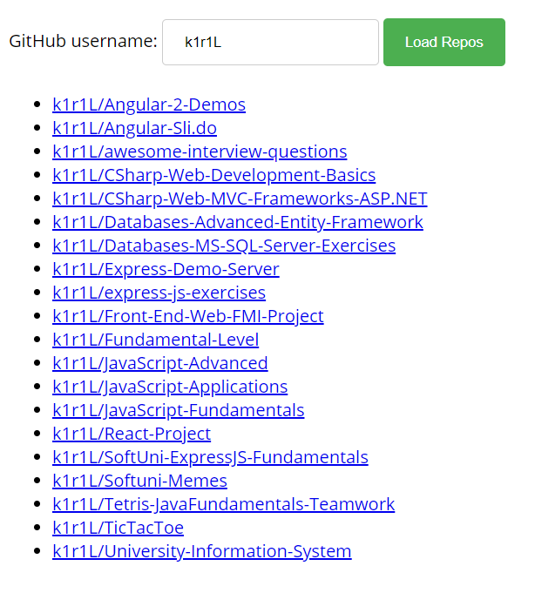

3. Github Commits
Write a JS program that loads all commit messages and their authors from a github repository using a given HTML.
The loadCommits() function should get the username and repository from the HTML textboxes with IDs "username" and "repo" and make a GET request to the Github API:
https://api.github.com/repos/<username>/<repository>/commits
Swap <username> and <repository> with the ones from the HTML:
- In case of success, for each entry add a list item (<li>) in the unordered list (<ul>) with id "commits" with text in the following format:
"<commit.author.name>: <commit.message>"
- In case of an error, add a single list item (<li>) with text in the following format:
"Error: <error.status> (Not Found)"

Screenshots:
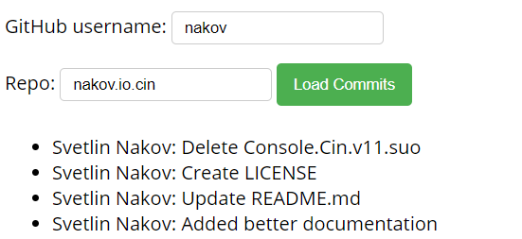
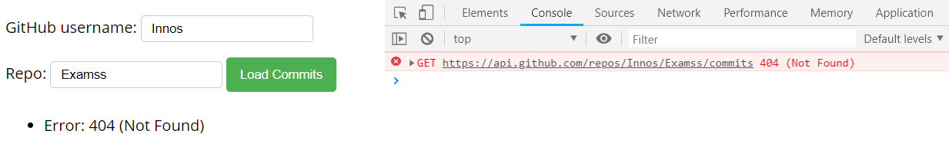

4. Bus Stop
Write a JS program that displays arrival times for all buses by a given bus stop ID when a button is clicked. Use the skeleton from the provided resources.
When the button with ID 'submit' is clicked, the name of the bus stop appears and the list bellow gets filled with all the buses that are expected and their time of arrival. Take the value of the input field with id 'stopId'. Submit a GET request to http://localhost:3030/jsonstore/bus/businfo/:busId (replace the highlighted part with the correct value) and parse the response. You will receive a JSON object in the format:
stopId: {
name: stopName,
buses: { busId: time, … }
}
Place the name property as text inside the div with ID 'stopName' and each bus as a list item with text:
"Bus {busId} arrives in {time} minutes"
Replace all highlighted parts with the relevant value from the response. If the request is not successful, or the information is not in the expected format, display "Error" as stopName and nothing in the list. The list should be cleared before every request is sent.
Note: The service will respond with valid data to IDs 1287, 1308, 1327 and 2334.
See examples on the next page.

Examples
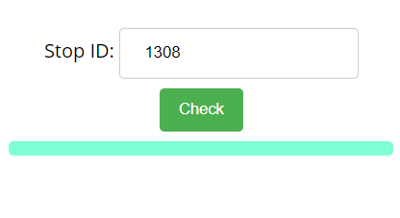
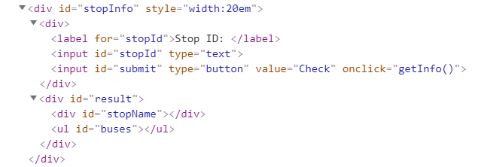
When the button is clicked, the results are displayed in the corresponding elements:
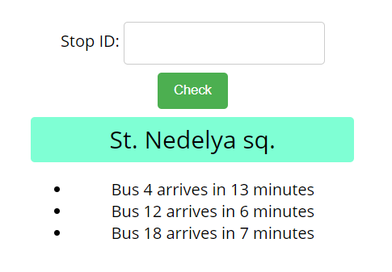
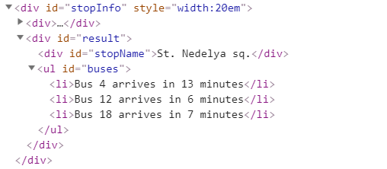
If an error occurs, the stop name changes to Error:
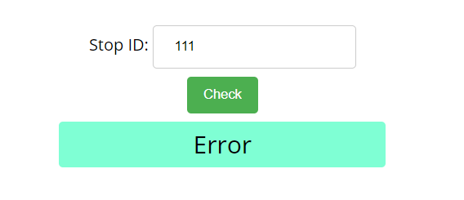
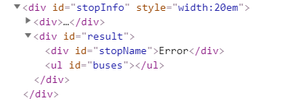

Bus Schedule
Write a JS program that tracks the progress of a bus on it’s route and announces it inside an info box. The program should display which is the upcoming stop and once the bus arrives, to request from the server the name of the next one. Use the skeleton from the provided resources.
The bus has two states – moving and stopped. When it is stopped, only the button “Depart” is enabled, while the info box shows the name of the current stop. When it is moving, only the button “Arrive” is enabled, while the info box shows the name of the upcoming stop. Initially, the info box shows "Not Connected" and the "Arrive" button is disabled. The ID of the first stop is "depot".
When the "Depart" button is clicked, make a GET request to the server with the ID of the current stop to address http://localhost:3030/jsonstore/bus/schedule/:id (replace the highlighted part with the relevant value). As a response, you will receive a JSON object in the following format:
stopId {
name: stopName,
next: nextStopId
}
Update the info box with the information from the response, disable the “Depart” button and enable the “Arrive” button. The info box text should look like this (replace the highlighted part with the relevant value):
Next stop {stopName}
When the "Arrive" button is clicked, update the text, disable the “Arrive” button and enable the “Depart” button. The info box text should look like this (replace the highlighted part with the relevant value):
Arriving at {stopName}
Clicking the buttons successfully will cycle through the entire schedule. If invalid data is received, show "Error" inside the info box and disable both buttons.

Examples
Initially, the info box shows "Not Connected" and the arrive button is disabled.
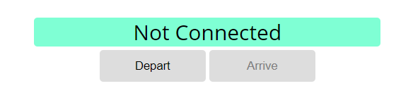
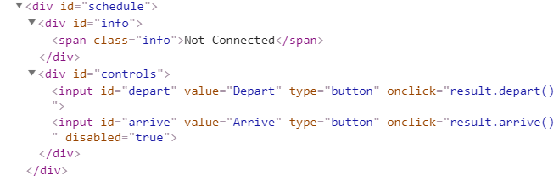
When Depart is clicked, a request is made with the first ID. The info box is updated with the new information and the buttons are changed:
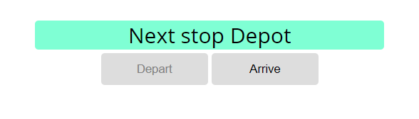
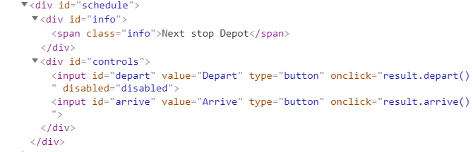
Clicking Arrive, changes the info box and swaps the buttons. This allows Depart to be clicked again, which makes a new request and updates the information:
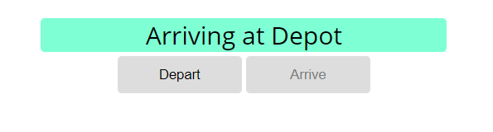
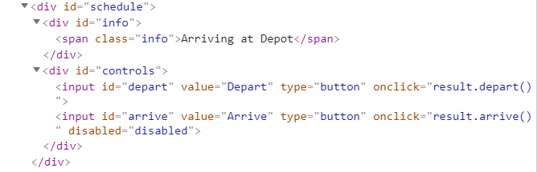

6. Forecaster
Write a program that requests a weather report from a server and displays it to the user.
Use the skeleton from the provided resources.
When the user writes the name of a location and clicks “Get Weather”, make a GET request to the server at address http://localhost:3030/jsonstore/forecaster/locations. The response will be an array of objects, with the following structure:
{
name: locationName,
code: locationCode
}
Find the object, corresponding to the name that the user submitted in the input field with ID "location" and use its code value to make two more GET requests:
- For current conditions, make a request to:
http://localhost:3030/jsonstore/forecaster/today/:code
The response from the server will be an object with the following structure:
{
name: locationName,
forecast: { low: temp,
high: temp,
condition: condition }
}
- For a 3-day forecast, make a request to:
http://localhost:3030/jsonstore/forecaster/upcoming/:code

The response from the server will be an object with the following structure:

{
name: locationName,
forecast: [{ low: temp,
high: temp,
condition: condition }, … ]
}
Use the information from these two objects to compose a forecast in HTML and insert it inside the page. Note that the <div> with ID "forecast" must be set to visible. See the examples for details.
If an error occurs (the server doesn’t respond or the location name cannot be found) or the data is not in the correct format, display "Error" in the forecast section.
Use the following codes for weather symbols:
- Sunny &#x2600; // ☀
- Partly sunny &#x26C5; // ⛅
- Overcast &#x2601; // ☁
- Rain &#x2614; // ☂
- Degrees &#176; // °

Examples
When the app starts, the forecast div is hidden. When the user enters a name and clicks on the button Get Weather, the requests being.
